# In this document we will discuss how to deploy the Email Reader logic app.

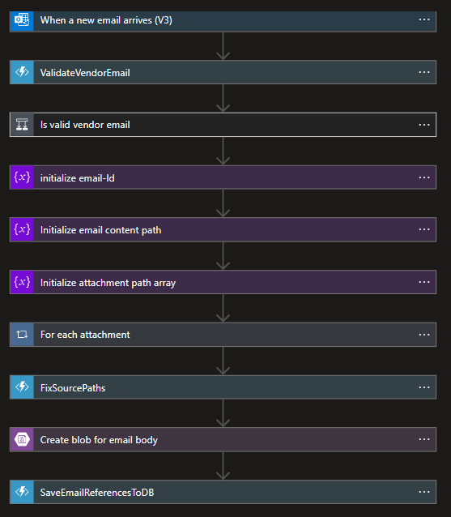The below image represents the flow of the Email Reader logic app.

The above image is a collapsed version of the Email Reader logic app. You can get the expanded with details in the documents folder for Email Reader logic app [here](email%20reader%20logic%20app%20flow.png).

Below in the json format of the logic app. The original json file is also added to the documents folder of the Email Reader logic app [here](email%20reader%20logic%20app.json).

Before you deploy or design the logic app again, there are dependent services on which the Email reader logic app depends on. So it is required to create those resources before the logic app.

1. Azure storage account
2. Azure function app.
3. **Azure Storage account**

An Azure storage account is required to store the email content and email attachments once read from the “**When a new email arrives”** trigger of the logic app.

The azure storage must have a blob container by the name “**emails**”. If it doesn’t exist, create a new container by the name “**emails**”.

1. **Azure function app.**

There a are 3 azure functions required by this logic app.

1. One function the validate the vendor email.
2. Another function which fixes the source URLs to the inline attached documents of the email html.
3. Last function to save the email details to the repository (database or any other permanent storage).

The azure functions are added in the project solution file.

The azure function has the following configuration which should be added to “local.settings.json” when debugging.

{

"IsEncrypted": false,

"Values": {

"AzureWebJobsStorage": "UseDevelopmentStorage=true",

"FUNCTIONS_WORKER_RUNTIME": "dotnet",

"BlobBaseUrl": "https://vpmsteststrgacc.blob.core.windows.net"

},

"ConnectionStrings": {

"DbConnection": "some db connection"

}

}

The original “local.settings.json” can be found [here](../function%20app%20docs/local.settings.json).

In production, use the same “**Key”** must be used in the Azure Function App configuration and add the required values.